

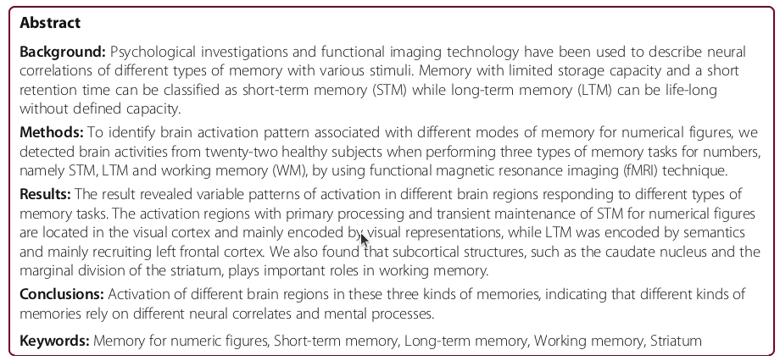

Short-term memory for numeric figures

Seven single-digit numbers were used as stimuli according to the average chunking capacity for seven digits [32].

Mathematically structured numbers (for example, 8,421,248) were eliminated to avoid the strategic encoding effect on the lateral prefrontal cortex [33].

During the experiment, after the word “Start” was shown on the screen for 1.5 s, a series of 7 Arabic numerical figures of single digit (ranged from 0 to 9, named memory sample) was shown in a random order at the center of the screen at the speed of 0.75 s per figure

followed by the word “Remember” shown on the screen for 1 s,

and then another series of 7 numeric figures (named probe) was shown in the same way at the same speed.

After these two series of numeric figures, the instruction “Judge” was displayed on the screen for 2 s for the subjects to determine whether the probe matched (digits and their order) the memory sample or not.

The subjects were asked to press a button if the two series were the same with their right hand and do nothing if they were not the same.

Hence each memory trials took 15 s (0.75 s × 7 × 2 + 2 s + 1.5 s + 1 s).

Two memory trials were repeated in each block.

In the control trials, a numeric figure (ranged from 0 to 9) was shown on the screen for 13 s, and then the question “Is it 5?” appeared on the screen.

The subjects were then asked to give an answer in 2 s by pressing the right-hand button for yes and doing nothing for no.

Control trial was repeated twice in each block.

